ITEM 1 OF 27
Topology | Task | Solutions
Guidelines  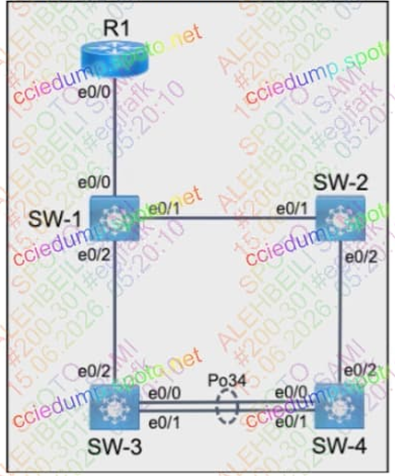  Please use the "Tasks" and "Topology" tabs to complete this lablet. | - All relevant ports are pre-configured as 802. Iq trunks.  - 2 Configure SW-I port EO/O to only permit VLANs 5 and 6.  - Configure SW-I and SW-2 ports e0/1 using VLAN 77 as the native VLAN_  - Configure SW-2 port EOt2 to only permit VLAN 6.  - using LACP, create a Port Channel On SW-3 and SW-4.  - Combine eO/O and eO/l into a port Channel while leaving the trunk configurations intact.  - Assign number 34,  - Only SW-3 must negotiate | 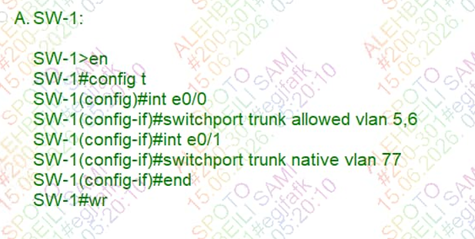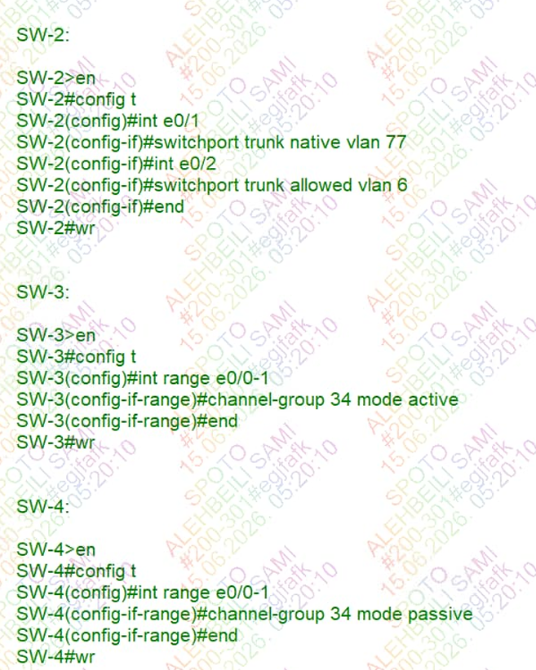

ITEM 2 OF 27
Topology | Task | Solutions
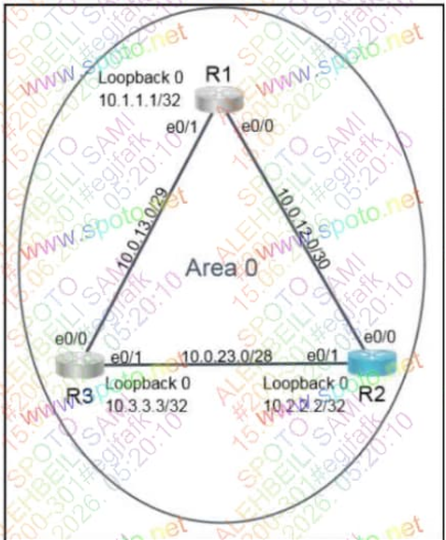 | - Configure OSPF routing for the network by completing the following tasks:  - Configure OSPF on R2, Ensure RI and R3 become neighbors.  - 1, use process IO 30  - 2 use 102222.22 as the router IO.  - Under the OSPF process. advertise the following specific prefixes.  10.0.23_0/28  10.0.12.0/30  - Ensure R2 always becomes the DR | 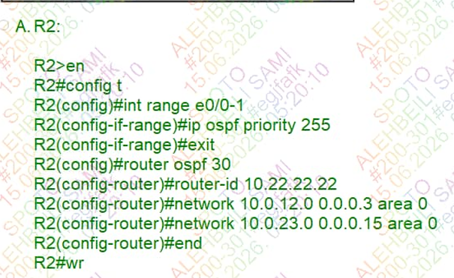

ITEM 3 OF 27
Topology | Task | Solutions
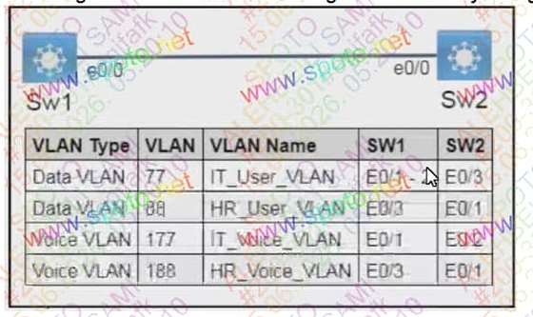 | - Configure SWI and sw2 With VLANS using the naming on the topology.  - Assign VLANs to the appropriate interfaces from the topology.  - Ensure ports are set to voice and data as assigned on the topology.  - Configure SWI and sw2 for neighbor discovery using LLDP | 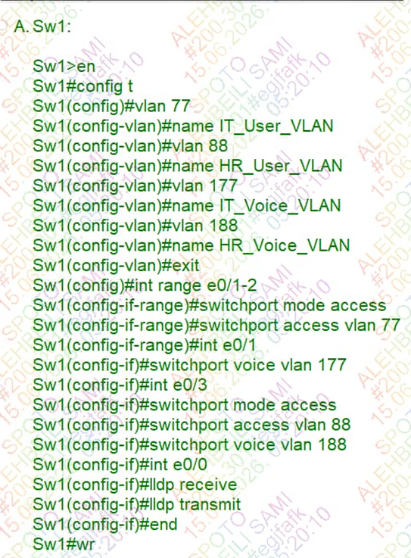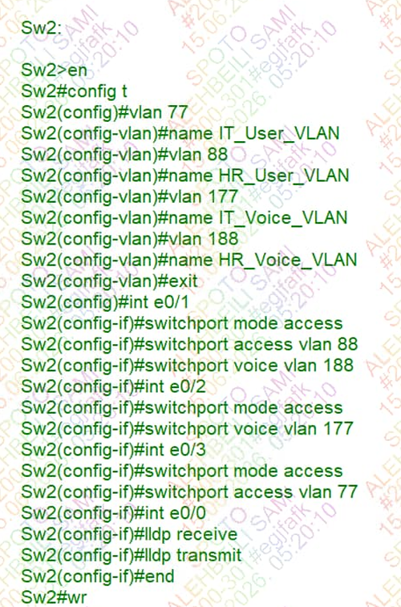

ITEM 4 OF 27
Topology | Task | Solutions
- Configure RI With the first usable host IP address in the 10.12.18.24/29 network.
- Configure R2 With the last usable host IP address in the IO. 12.18.24/29 network.
- Configure RI With the first usable host IP address in the 2001 network.
- Configure R2 With the last usable host IP address in the network.

